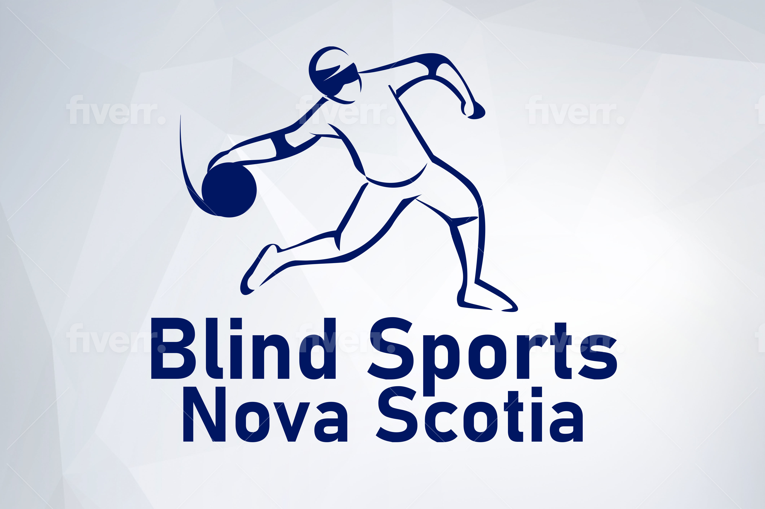
3383 St Andrews Ave
Halifax, NS B3L 3Y2
www.blindsportsnovascotia.ca
BlindSportsNS@gmail.com

Hello!

Blind Sports Nova Scotia is excited to host the 2026 edition of our annual Charity Auction on Saturday, June 20. This is our most successful fundraiser, thanks to the kind generosity of valued community members like you, who have contributed auction items.

Supporting this fundraiser furthers our mission: Creating competitive & recreational opportunities in sport for Nova Scotians who are blind, of all ages and experience, even representing Nova Scotia at national & international competition.

Donations big & small are welcome, and can include anything from gift certificates to merchandise to artwork, plus everything in between. We love to support & promote our favourite local businesses through this exciting fundraising event!

Your donated auction item will help grow programs & activities across the province, such as competitive & recreational goalball, tandem biking, and Blind Sports Nova Scotia’s community partnerships in awareness & access.

To arrange a donation, contact
Name: Linda MacRae Triff
Email: mactlinda@gmail.com
Phone: 902 448 6235

Event Details
Saturday, June 20
6 to 9 PM
Freeman’s 3671 Dutch Village Rd. Halifax
$5 at the door to bid

Thank you for your Support!

CCB Blind Sports NS

